Posted 08/11/2011 at 1:00 pm by JAV

Municipal Building Committee

Agenda
Old Library, Fireplace Room
Tuesday, August 16, 2011
7:30 AM

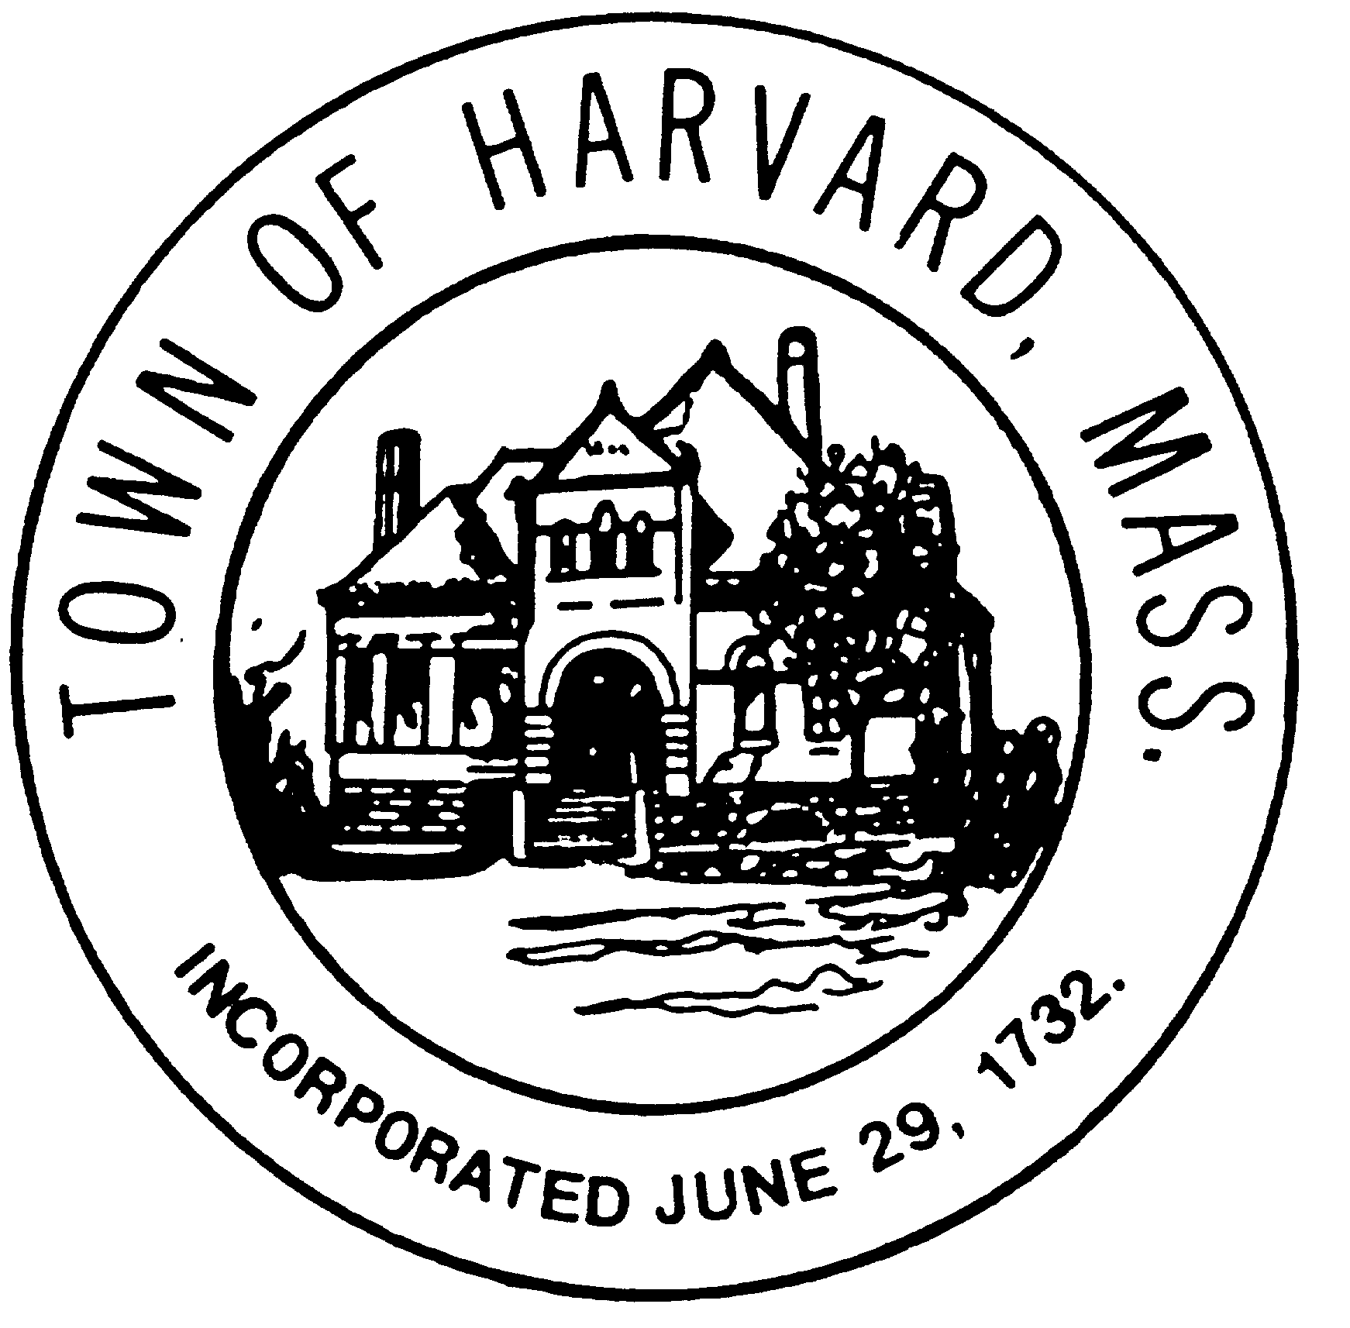
- Approve minutes

- Prepare for interviews of OPM candidates

- Review of RFP for Architect

- Draft Work Plan

- Agenda for next meeting

